Project Design Phase-II
Data Flow Diagram & User Stories

Date | 30 September 2026
Team ID | SWTID-2026-1800
Project Name | AI FITTRACK API
Maximum Marks | 4 Marks

Data Flow Diagrams:
A Data Flow Diagram (DFD) is a traditional visual representation of the information flows within a system. A neat and clear DFD can depict the right amount of the system requirement graphically. It shows how data enters and leaves the system, what changes the information, and where data is stored.
Level 0 DFD (Context Diagram) - AI FITTRACK API:
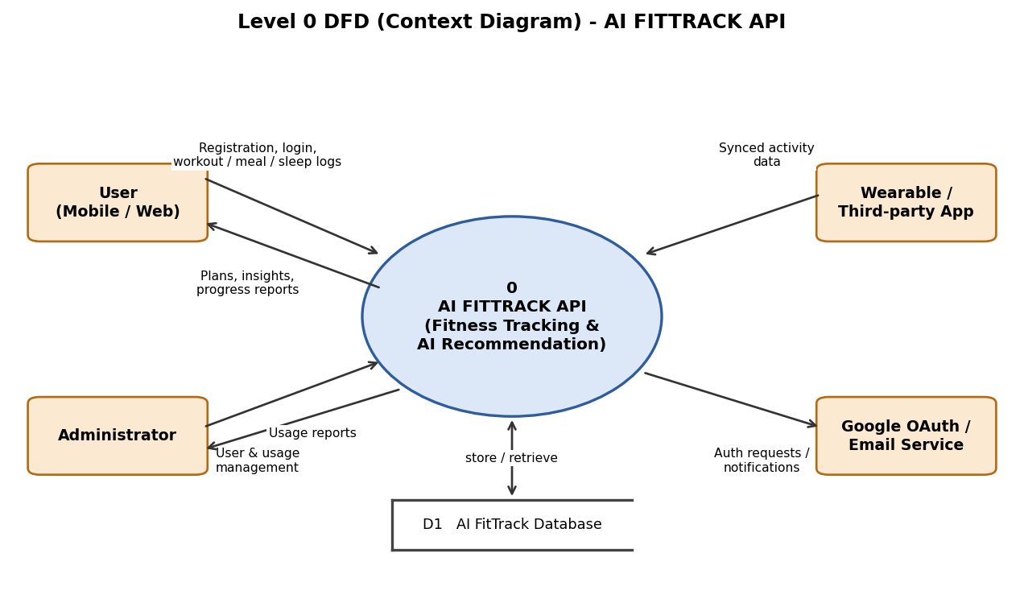
Level 1 DFD - AI FITTRACK API:
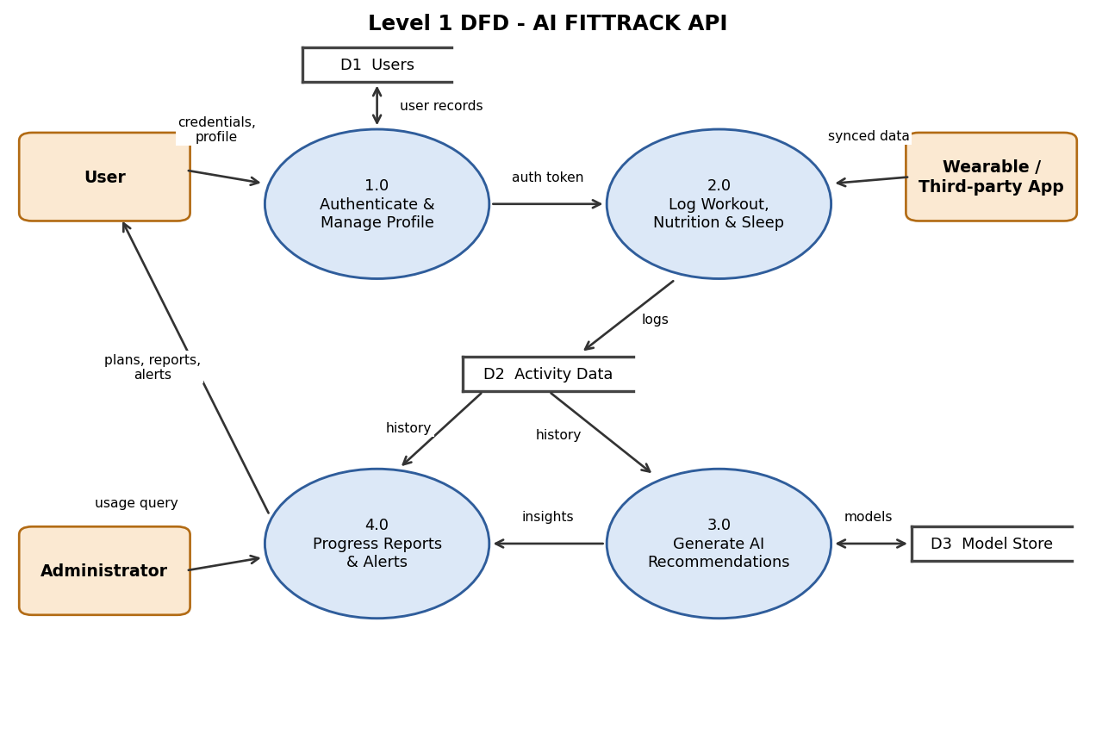

User Stories
Use the below template to list all the user stories for the product.
User Type | Functional Requirement (Epic) | User Story Number | User Story / Task | Acceptance criteria | Priority | Release
Customer (Mobile user) | Registration | USN-1 | As a user, I can register by entering my email, password and confirming my password. | I can access my account / dashboard | High | Sprint-1
 |  | USN-2 | As a user, I will receive a confirmation email once I have registered. | I can receive a confirmation email and click confirm | High | Sprint-1
 |  | USN-3 | As a user, I can register through my Google account. | I can register and access the dashboard with Google login | Medium | Sprint-1
 | Login | USN-4 | As a user, I can log in by entering email and password. | I receive a secure token and reach my dashboard | High | Sprint-1
 | Profile | USN-6 | As a user, I can create my profile with age, height, weight and goal. | My profile is saved and shown on the dashboard | High | Sprint-1
 | Workout & Nutrition Tracking | USN-9 | As a user, I can log workouts, meals and sleep. | Entries are saved and visible in my history | High | Sprint-2
 | AI Recommendations | USN-16 | As a user, I receive a personalised weekly workout plan and calorie targets. | A plan matching my goal is returned | High | Sprint-3
 | Progress Reports | USN-20 | As a user, I can view my weekly progress report. | Report shows totals, trends and goal progress | High | Sprint-3
Customer (Web user) | Dashboard | USN-7 | As a web user, I can view my activity summary and charts in the browser. | Dashboard loads with my latest data | Medium | Sprint-1
Developer (API user) | Developer Access | USN-8 | As a developer, I can get an API key and read the API documentation. | I can call the API successfully using my key | High | Sprint-1
Customer Care Executive | Support | USN-23 | As a customer care executive, I can look up a user's account status and recent activity to resolve queries. | I can view account details without seeing the password | Medium | Sprint-4
Administrator | Administration | USN-23 | As an administrator, I can manage users and monitor API usage. | I can view, disable users and see usage statistics | Medium | Sprint-4

